HEAT TRANSFER
Refer to the following information for the next four questions.

The tips of both brass rods are held in the gas flame. Mark each of the following as True or False.

- Heat is conducted only along Rod A.

True | False

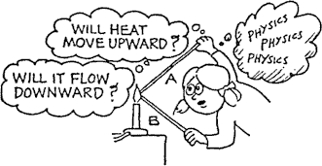
- Heat is conducted only along Rod B.

True | False

- Heat is conducted equally along both Rod A and Rod B.

True | False

- The idea that "heat rises" applies to heat transfer by convection, not by conduction.

True | False

- Why does a bird fluff its feathers to keep warm on a cold day?

- Why does a down-filled sleeping bag keep you warm on a cold night? Why is it useless if the down is wet?

- What does convection have to do with the holes in the shade of the desk lamp?

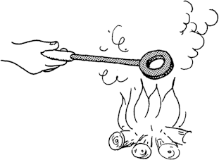

- When the temperature of a metal ring increases, does the hole become larger, smaller, or remain the same size

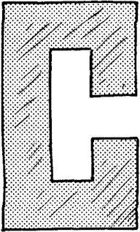

- When the temperature of the piece of the metal is increased and the metal expands, will the gap between the ends become narrower, or wider, or remain unchanged? Explain.

- The air temperature at an altitude of 10 kilometers is a chilling -35ºC. Cabin temperatures in airplanes flying at this altitude are comfortable because of air conditioners rather than heaters. Why?

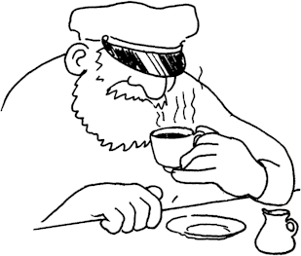

- Suppose in a restaurant your coffee is served about 5 or 10 minutes before you ask for it. In order that it should be as hot as possible when you drink it, should you pour in the room temperature cream right away or when you are ready to drink the coffee? Explain.

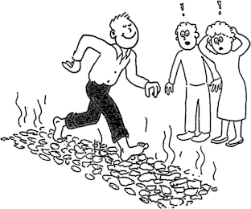

- He can quickly walk barefoot across red hot coals of wood without harm because of .

- mind over matter
- reasons that are outside mainstream physics
- basic physics concepts

- A candle will stay lit inside the space shuttle when it is on the launch pad, but not when it is in orbit. Why?

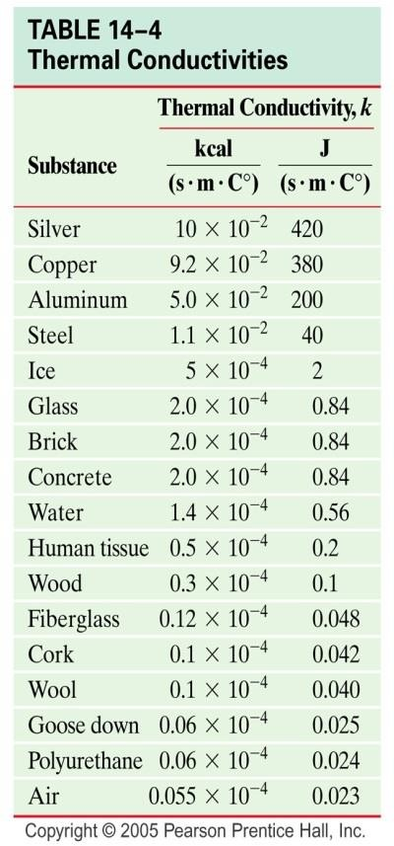

- Good silverware (knives, forks, and spoons) has an actual silver coating. Is thermal conductivity a consideration here? Explain.

- Why do underground water pipes sometimes freeze only after it has been very cold for several days?

- A medical emergency arises and you are told to boil some water quickly. In the kitchen you find two similar pots, one made of iron and the other of aluminum. Which one would you use? Why?

- (a) Is baked food more likely to “burn on the bottom” in an aluminum baking pan or a glass baking dish?

  - Counter tops in restaurants are sometime made “burn proof” from cigarette burns by pressing a sheet of aluminum foil between the layers of varnished paper just below the plastic top during the manufacturing process. How does this help prevent burn marks when a lighted cigarette comes into contact with the counter?

- How would the rate of thermal conduction (conductivity) of the bottom of a metal cooking pan vary with (a) area and (b) the thickness? (Hint: Think in terms of heat “flow”)

- Why do some metal pans (usually iron or steel) have a layer of copper on their bottoms? Is this only for looks?

- Thermal underwear has a knitted structure with lots of holes. Wouldn’t a material without holes be a better insulator? Explain.

- A bucket-brigade analogy is used to illustrate the molecular conductive process. Suppose a real bucket brigade passed buckets of hot water along the line. What type of actual heat transfer process is this?

- Thermopane windows have double panes of glass separated by a small air space. Why are these windows better for insulation than single-pane windows? How do storm doors and windows help reduce your heating bill?

- Foam insulation is sometimes blown between the outer wall and inner wall of a house. If air is a poor conductor, why bother with the insulation?

- The outside coils of window air-conditioners have a fin network. What is the purpose of these fins?
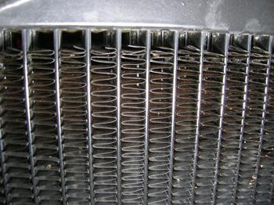
- A big roaring fire in a fireplace is only about 10 percent efficient in heating a room. Why the low efficiency?
- Discuss the energy balance and average temperature of the Earth if it’s only heat-loss mechanisms were conduction and convection.

- (a) Why do we general wear dark clothes in the winter and light-colored clothes in the summer?

  - On a hot, sunny summer day, it is possible to cook an egg on the hood of a car. Could this be done faster on the hood of a black car or the hood of a white car? Explain.

- Homemakers often complain that their pie crusts do not brown on the bottom in shiny aluminum pie pans as they do in the older metal pie pans. Why is this?

- A Thermos bottle is used to keep cold liquids cold and hot liquids hot. It consists of a double- walled, partially evacuated container with silvered walls. Discuss how heat transfer is impaired in terms of conduction, convection, and radiation.
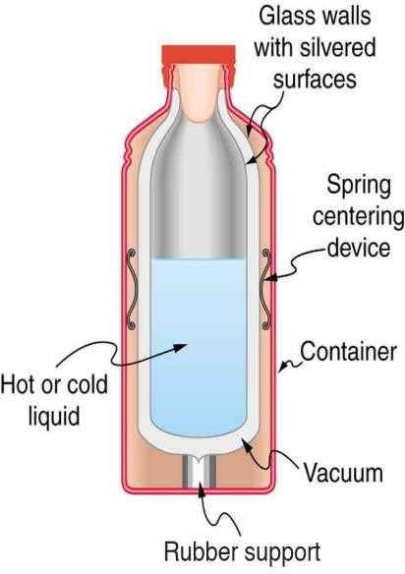
- (a) When your skin is hot, the blood vessels in the skin dilate, or get larger in diameter. When the skin is cold (below 370C), the blood vessels constrict. What is the purpose of this action?
  - Alcohol (taken internally) causes the blood vessels in the skin to dilate, and drinkers feel a
warm “glow.” Is this really a warming process for the body? What if drinkers are seating in a hot- tub for long periods of time? Explain.

- When foods are broiled in an oven or a “toaster” oven, a heating element in the top of the over is used. What’s the purpose of this? Wouldn’t a bottom element be more efficient in heating?

- (a) In heating frozen foods in sealed pouches, why do you first poke holes in the pouch? (b)Why are microwave ovens built so they will not operate with the doors open?
(c) What is the purpose of the metal grating on the inside of the glass in the door?

- REVIEW: When you eat a hot apple pie, you may find that the crust is only warm, but yu may burn your mouth on the apple filling. Why is this?

- REVIEW: If equal amounts of heat were added to two containers of water and the temperature change of the water in one of the containers was twice that of the other water, what could ou say about the quantities of water in the containers?

- On vacation, at a Southern California beach, the sand may be very hot to your feet, but the water is relatively cool. What does this tell you about the specific heats of sand and water? (Assume, summer mid-day).

Refer to the following information for the next three questions.

36. A person brings a cup of hot chocolate (70°C) into a room (20°C) and places a metal spoon (20°C) into the hot chocolate.

- Describe what happens to the temperatures of the hot chocolate, the spoon, and the air in the room after 10 minutes. Explain your answer.

- Identify and describe the primary method of heat energy transfer (conduction, convection, or radiation) between each of the following:

  - the hot chocolate and the spoon
  - the hot chocolate and the air in the entire room

- At what point will the net transfer of heat energy stop?

37. Calorimeters are instruments used to measure heat. The diagrams below show a calorimeter before a metal sample is added and after the sample is added.
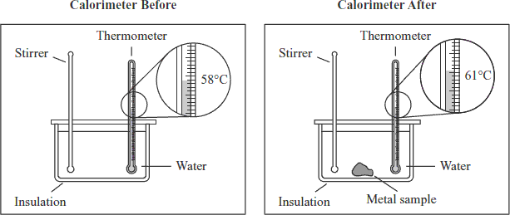

Which of the following statements describes the flow of heat energy after the metal sample is added?

A. Heat energy flows from the stirrer to the thermometer.
B. Heat energy flows from the water to the metal sample.
C. Heat energy flows from the metal sample to the water.
D. Heat energy flows from the insulation to the thermometer.

